RISK MANAGEMENT FOR MEDICAL DEVICES

Function: | Prepared by: | Reviewed by: | Approved by:
Department: | Quality Assurance | Development | Quality Assurance
Name: | Esther Arnaiz | David Pozo | Ivan Perez
Signature:
Date: | July 15, 2024 | July 15, 2024 | July 15, 2024

Valid until: | 07/15/2027

DOCUMENT HISTORY
VERSION | CAUSES OF MODIFICATION | EFFECTIVE DATE | REPLACES (Code, Revision)
01 | Initial edition | July 15, 2024 | N/A

Content
1. Objective 4
2. Scope 4
3. Responsibilities and Departments affected 4
4. Definitions and Acronyms 5
5. Procedure 5
5.1. Generalities 5
5.2. Risk management method 6
5.3. Risk analysis 7
5.4. Risk management plan 10
5.5. Risk Review 10
5.6. Risk Management File 11
6. Distribution of Procedure 11
7. Annexes 11
8. Related documentation 12
8.1. Training 12

- Aim
The objective of this procedure is to describe the guidelines to follow for managing risks associated with the use of medical devices.
This procedure complements PNT002 Risk Management, as it provides a general approach to both the product and any derived processes for obtaining a medical device. However, this specific procedure is intended to delve only into the risk analysis to be developed to identify, control, and analyze the risks derived from and/or associated with the use of a medical device, in this case VR-CARDIO or all medical devices developed by SPIKA TECH, hereinafter SPIKA. This procedure is based on the principles described in Standard UNE EN ISO 14971 Medical devices/medical devices (MD). Application of risk management to MD.
- Scope
This procedure applies to all risk analyses of medical devices carried out by SPIKA.
- Responsibilities and Departments Affected
SPIKA staff are responsible for collaborating in the flow of information to compile risk analyses of medical devices.
Quality Assurance
The Responsible Technician will be the primary contact with the competent authorities, always relying on the responsible collaborating personnel in each case to resolve these issues.
The affected departments are the following:
Department | Apply
 | Yeah | No
Address | ☒ | ☐
Quality Assurance | ☒ | ☐
Logistics and warehouse | ☒ | ☐
Investigation | ☒ | ☐
Development | ☒ | ☐
Marketing and communication | ☒ | ☐
ITEM | ☒ | ☐
Robotics | ☒ | ☐
Clinical studies | ☒ | ☐

- Definitions and Acronyms
- Damage: injury or harm to the health of people, or damage to property or the environment.
- Hazard: potential source of harm.
- Intended use: or intended purpose, is the use for which a product, process or service is designed in accordance with the specifications, instructions and information provided by the manufacturer.
- Residual risk: Risk that remains after risk control measures have been implemented.
- Risk: combination of the probability of occurrence of damage and the severity/gravity of such damage.
- AR : Risk Analysis-

- Procedure
  - Generalities
During the development or manufacture of a medical device, risks related to injury may be identified, not only to patients but also to users and other persons. The risks of a medical device may be related to damage to property—i.e., objects, data, or other equipment—or to the environment.
Risk management is often a complex issue because each stakeholder may assign a different value to the acceptability of risks relative to the expected benefits. SPIKA, to the extent possible, will be as objective as possible, focusing on patient safety and contributing significant advances in the development of diseases.
Risk management for the use of medical devices will be based on three key components:
- Probability of damage occurring
- Severity or consequences of that damage
- Detectability of damage
It is important to note that the use of a medical device always carries a degree of inherent risk; even after the risks have been reduced to an acceptable level, certain residual risks may remain.

  - Risk management method
The necessary tools will be established to establish, implement, document and maintain a continuous process that:
- Identify the hazards and dangerous situations associated with the product
- Estimate and evaluate the associated risks
- Controlling risks
- Monitor the effectiveness of risk control measures
These concepts will be applied to the entire product life cycle following the scheme shown below:
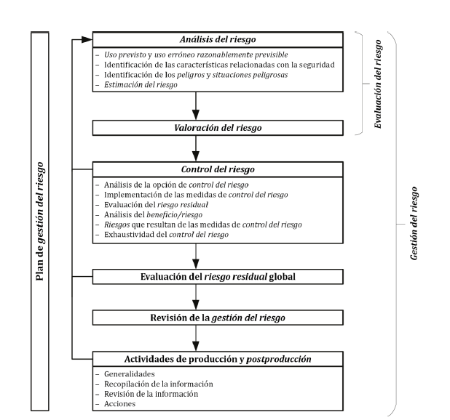
To implement this risk management, SPIKA Management will provide adequate resources and assign competent personnel for risk management. Likewise, the personnel involved in risk management tasks will be competent based on education, training, skills, and experience appropriate to the assigned tasks.
  - Risk analysis
The analysis of the risks associated with the use of a medical device will be at least the following:
- Intended use and reasonably foreseeable misuse : Information such as the intended medical indication, the target patient population, and whether there are body parts in direct contact or that may interact should be taken into account. Similarly, the environment in which the product is used, the user profile, the environment, and how the product functions should be evaluated.
- Security : The identification of qualitative or quantitative characteristics related to security must be taken into account.
- Hazards and dangerous situations : Known and foreseeable associated hazards should be defined based on foreseeable use and misuse.
A risk matrix will be used to number risks, identify their cause and potential damage, and quantify the following parameters: probability, severity/severity, and detectability.
Generally, however, other quantifications may be available from 1 to 3, as follows:

 |  | SCORE (Description)
 |  | 1 | 2 | 3
PARAMETER | PROBABILITY | Low | Average | High
 |  | Unlikely or unlikely to occur, infrequent, remote, isolated. | It can happen, but not frequently, occasionally. | Possibly occurring, often, frequently, almost unavoidably.
 | SEVERITY/SEVERITY | Insignificant | Moderate | Significant
 |  | The type of failure would cause imperceptible or irrelevant repercussions, only in the production area and without affecting the customer. It is easily correctable. | The type of failure would cause minor inconveniences in production and/or for the customer. | This type of failure would cause serious inconveniences or consequences, making production impossible and/or harming the customer's health.
 | DETECTABILITY | High | Moderate | Low
 |  | The defect is obvious; it is unlikely to be detected by existing controls (quality control/production). It could escape an initial control, although it would almost certainly be detected later. | The defect is detectable and may not reach the customer, but it would be detected in the final stages of production. | The defect is difficult to detect or cannot be detected by existing controls, it could reach the customer.
Once the three variables have been scored, the RPN or risk priority number will be calculated as follows:
RPN = P x S x D
Being able to obtain the following scores:
RPN ≤ 6 | The process has LOW risk.
6 < RPN ≤ 18 | The process has MEDIUM risk.
RPN > 18 | The process has HIGH risk.

After this numerical assessment, it will be identified whether there are controls implemented in the organization or if additional controls are required. After this, the risks will be re-evaluated numerically with the scores and it will be identified in each case if there are residual risks.
When controls need to be implemented that do not exist at the time of the analysis, corrective and/or preventive actions will be initiated, as appropriate, to implement and monitor these actions. It is recommended that the code for the generated actions be included in the conclusions of the risk analysis report, according to PNT006 Management of Corrective and Preventive Actions.
If there are residual risks that are not considered acceptable and additional risk control is not feasible, data and publications should be collected and reviewed to determine whether the benefits of the intended use outweigh this residual risk.
In specific cases, it should be noted that if the benefits do not outweigh the residual risks, a modification of the product or its intended use may be considered; otherwise, these unacceptable residual risks would not be acceptable.
In this way, the overall residual risk will be assessed, and when it is not considered acceptable compared to the benefits of using the product, additional risk control measures should be considered. When acceptable, users must be informed of these residual risks in the information accompanying the product. All these decisions must be documented in the Risk Analysis exercise.

  - Risk management plan
Risk management activities must be planned, and SPIKA will document the process to be analyzed in a plan document.
This plan must include the following sections:
- Introduction
- Scope
- Responsibilities
- Risk assessment
- Risk acceptance
- Verification activities
- Production and post-production information
- Usability
- Residual risk
- Plan review
- Conclusions
  - Risk review
SPIKA is constantly assessing risks, and before a product is released for marketing, it has the risk management reviewed and implemented in accordance with its risk management plan.
The product risk analysis may be reviewed whenever deemed necessary or when required by the quality management system, whether due to customer feedback, conclusions from management's annual system review reports, market complaints, etc. This includes the design and development phases, as well as the marketing and post-production phases.
The following information will be inputs for a possible risk review: monitoring information generated by users and internal staff, among others.
  - Risk Management File
Risk analysis documents will be coded as described in PNT 002 Risk Management and will be filed in paper format, duly signed, in the Quality Assurance Archive, and in electronic format after their signature on paper.

- Distribution of the Procedure
Staff members in the departments listed in Section 3 (Responsibilities and Affected Departments) must be provided with a copy of this procedure. In addition, controlled copy No. 1 will be submitted to the Archives for paper archiving.
Controlled copies to be issued:
Controlled Copy No. | Departments
1 | Archive
2 | See section no. 3

- Annexes
NO. / REV. | QUALIFICATION
N/A | N/A

- Related documentation
Code | QUALIFICATION
MQ-01 | Quality Manual
N/A | UNE EN ISO 13485 Medical Devices
N/A | ISO 14971:2019
PNT002 | Risk management
PNT006 | Management of Corrective and Preventive Actions
  - Training
This version requires that the affected departments indicated in section 3 receive the training indicated below:
Mark with an X | Type of training
☒ | Theoretical (reading and understanding of the procedure)
☐ | Theoretical – Practical (If you select this option, contact the Responsible Technician)

